 NARROGIN SENIOR HIGH SCHOOL

English ATAR Year 11

Student: Teacher:

Date Given: Date Due:

Task 4
Assessment Type: Creating

Photo Voices:

Part A:
- Students select and accurately reference an image that represents an aspect of Australian identity – choose from 3
- Extensively annotate the image as per model

Part B: Students compose an original narrative bringing ‘voice’ to the image.

Part C: Students reflect upon their construction of voice

Narrative and Reflection composed in class (under test conditions)

Time allocation: 60 minutes in class to compose narrative; 30 minutes in class on reflection

Weighting: Creating 5%

Marks Part A: / 10
Marks Part B: / 30
Marks Part C: / 10

To be assessed for this task you must submit on the day of the assessment: | Date Due | YES | NO
Extensively annotated image - completed at home
Image correctly referenced - completed at home
Narrative completed in class- completed in class in one period
Reflection completed in class

Teacher Feedback:

Part A Marks Allocation | /10
Extensively annotated image under the headings: context, symbolic, written, technical codes. | 8
Correct referencing of an image | 2

Part B Creating Marking Criteria and Categories | Marks /30
Language, language features, expression and style | /10
Controls language and language features for precision, fluency of expression and stylistic effect to create a strong voice. | 8-10
Uses language and language features for clarity of expression and development of style to create a voice. | 6-7
Uses some language and language features appropriate to purpose and style of expression to create a voice. | 5-6
Uses a limited range of language and/or language features and clarity of expression is limited to create a voice. | 3-4
Uses a minimal range of language and/or language features and clarity of expression is incoherent to create a voice. | 1-2
Mechanics of grammar, spelling and punctuation | /5
Sustains control of the mechanics of grammar, spelling and punctuation. | 5
Controls most of the mechanics of grammar, spelling and punctuation. | 4
Controls some of the mechanics of grammar, spelling and punctuation. | 3
Demonstrates limited control of the mechanics of grammar, spelling and punctuation. | 2
Demonstrates minimal control of the mechanics of grammar, spelling and punctuation. | 1
Purpose, audience, genre | /5
Controls the relationships between purpose, audience and genre. | 5
Applies a clear understanding of purpose, audience and genre. | 4
Uses some understanding of purpose, audience and/or genre. | 3
Demonstrates limited understanding of purpose, audience and/or genre. | 2
Demonstrates minimal understanding of purpose, audience and/or genre. | 1
Structure | /5
Sustains control of an effective narrative structure. | 5
Selects and controls most elements of narrative structure. | 4
Controls some elements of narrative structure. | 3
Provides limited evidence of narrative structure. | 2
Demonstrates minimal evidence of narrative structure. | 1
Context | /5
Integrates an understanding of context to engage audience. | 5
Uses an understanding of context to engage audience. | 4
Uses some understanding of context to engage audience. | 3
Makes limited connection between context and audience. | 2
Connection between context and audience is unclear. | 1

Reflection | /10
Considered, detailed reflection, evaluating level of success in constructing voice

Student brief

Voice/Voices in texts:
- Authorial voice - In the literary sense, voice can be used to refer to the nature of the voice projected in a text by an author; the persona, role or character adopted by an author.
- Narrative voice - The ways in which a narrator may be related to the story. For example, the narrator might take the role of first or third person, omniscient or restricted in knowledge of events, reliable or unreliable in interpreting what happens.
- Polyphonic voices - multiple voices. These are the views, positions, ideas and perspectives of other individuals or groups. It is important to recognise the various voices in a text, how they relate to one another, and how the creator of a text uses these to shape audience response.

Image One: Australian Lockdown Protests 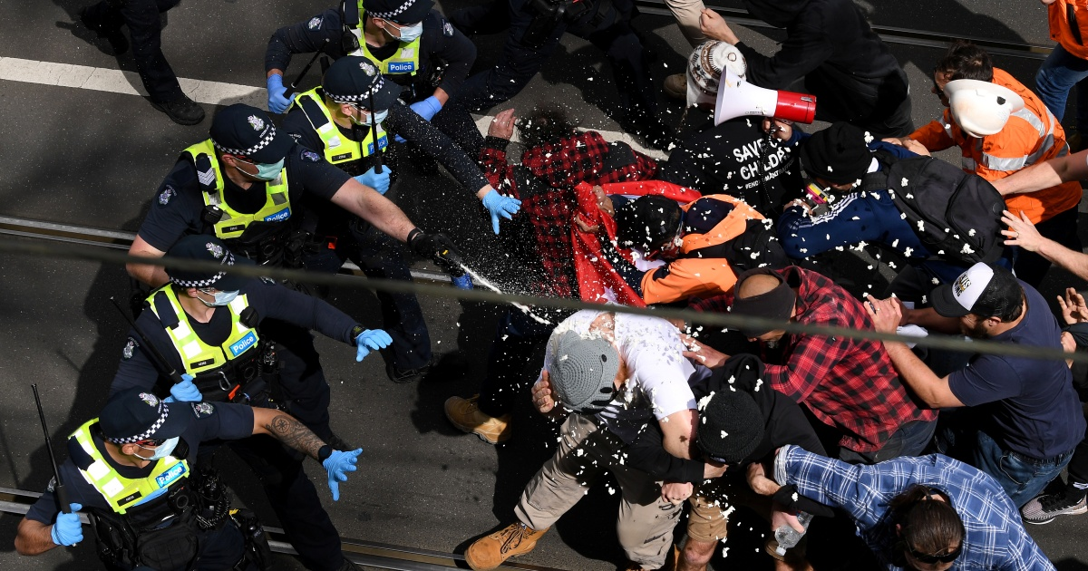
https://www.aljazeera.com/news/2021/9/18/hundreds-arrested-australia-anti-covid-lockdown-protests

Image Two: 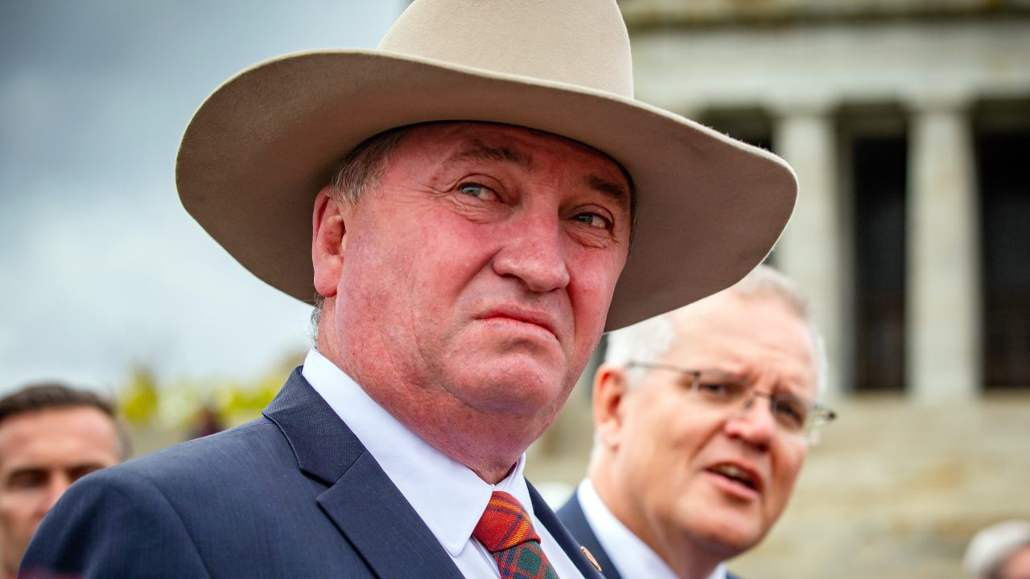
https://www.skynews.com.au/

Image Three: One year since Australia’s devastating fires, anger over climate ‘inaction’

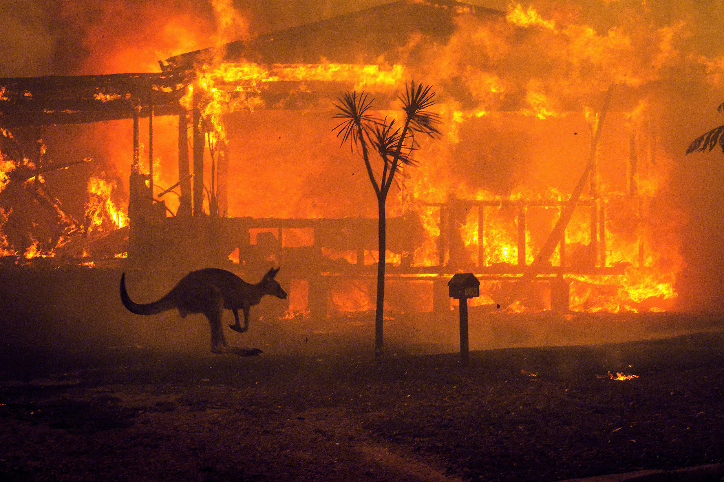
https://www.nbcnews.com/science/environment

